Website Profile for [www.champlainscreen.ca](http://www.champlainscreen.ca)

**Our Team**

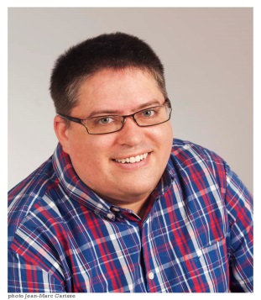

**Dmitri Bajorek** joined the SCREEN team in winter 2014 as an Administrative Assistant. His role on the team is to provide logistics and administrative support. He brings administrative experience from the private, public and non-profit sectors and has held various positions from bank teller to flight attendant to mental health worker in his varied career. Most recently, he was offering clients service in English and French to help them obtain training programs with a Quebec-based training company. He is fluently bilingual in English and French and has a working knowledge of Russian. He is well travelled having studied Russian in St. Petersburg and taught ESL in South Korea.

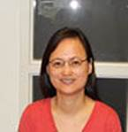

**Ling Wang** is one of the Community Health Workers in the SCREEN team.  Ling has more than 12 years of experience working with multicultural communities in various positions including LINC Program Assistant, Multicultural Liaison Officer, and Immigrant Settlement Outreach Worker.  Her main role in the SCREEN program is to collaborate with Community Health and Resource Centres and community-based organizations to bring the screening sessions to high risk communities.  She is fluent in English and Mandarin and she likes to read and listen to music.

**Marlyse Anakeu**

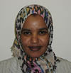

**Entisar Yusuf, Program Coordinator**

Entisar has 18 years of experience working in health and social sectors in public, non-profit organizations and UN agencies. She worked as clinical service provider, instructor in academic institutions and coordination and management of several health and social programs including Mitigation of Female Genital Mutilation, Child Welfare, Quality Improvement of Health care providers Education and Curriculum Development. Moreover she worked on Income Generating Activities for widowed women and Community Engagement Programs.

As a natural leader in the Ottawa and Champlain region community, she supervises health promotion/outreach workers on the SCREEN team and collaborates with identified high risk and immigrant communities, community leaders, community health centres, chronic disease partners, settlement agencies, and project outreach workers to identify community needs and capacities, develop strategies, and implement diabetes screening event models as per the communities’ unique requirements. In addition to project management, Entisar is adept at community organizing, building community networks, communication strategies and coalition building.

She is well travelled and has participated in international workshops. Most recently, Entisar has worked as a community developer with the SCREEN program and volunteered with the City for All Women Initiative (CAWI) as the network coordinator for community engagement facilitators and is a member of their Steering Committee.